Stimulus
The music – Til Enda by Olafur Arnalds. The importance of being free to express yourself as an individual and through hip-hop movement
Lighting
Blue wash, blue pools, white sidelight from off stage. Purple on cyclorama.
Performance Environment
Proscenium arch
Costume
Blue t-shirts and jeans. Tattoos and jewellery. Grey trainers white sole
Choreographer
Kendrick Sandy
Dance Style
Hip-hop (poppin’ lockin’ waackin’ breakin’ krumpin’)
Aural Setting
Urban dubstep style music. Classical sections. Repetitive beats and sounds. Repeated vocal ‘The One’.
GCSE Dance Knowledge Organiser – Emancipation of Expressionism

Costume Contributions
Stimulus – Expressing individuality – allowance of personal jewellery, hairstyles and tattoos reflects the stimulus of expressing yourself.
Intention – Intention of ‘Order and Chaos’ is shown as all dancers wearing the same creates order
Mood – dark coloured clothing contributes to a dark and serious mood.
Complements other components – use of blue colour complements the blue lighting
Uniformity – all dancers wearing the same creates uniformity
Gender – costumes are gender neutral which represents equality despite of gender
Sculpts body – although not tightly fitted, the shapes of the sleeves allow the lower arm to be seen while performing intricate gestures.
Historical context – clothing suggests modern day as is typical urban style seen worn from 1990’s onwards.
Social context – simple costumes suggests the social context is of middle-lower social class.
Dancers
17
9 male
8 female

Themes
Order, chaos, unity, individuality

Lighting Contributions
Stimulus – Freedom of expression – spotlights highlight dancers to express themselves in their own moment in the ‘limelight’.
Theme – Order and Chaos – flashing lights create a sense of chaos
Mood – dark intensity creates an intense mood
Complements other components – Blue colour complements blue costumes
Highlights dancer – spotlights highlights dancers in their solos
Sculpts body – side light sculpts the bodies of the dancers as they scramble towards it
Highlights dance space – sides not lit to create a central focus, centre of the stage is lit
Context – blue creates a sense of liquid, as though inside a womb.
Aural Setting Contributions
Stimulus – Individuality – use of the vocal ‘The One’ suggests individuality and being ‘one’ or unique.
Intention – Order and Chaos – rapidly changing tempos and beats create a sense of chaos.
Mood – Use of classical section uplifts the mood to a hopeful one
Complements other components – use of fluid sounding classical music complements the liquid style lighting creating a sense of being submersed in water.
Historical setting – the music starts very modern with dubstep type beats, but progresses to classical music suggesting a step back in time.
Climax – Til Enda is used as a climax for the piece contrasting with the previous sections
Structure – Each of the 4 sections has its own distinctive section of aural setting aiding the audiences following of the structure.
Set Contributions
Stimulus – Free to express through hip-hop – No set = no distractions from the movement
Intention – Life’s journey – dark and secluded set creates a sense of a womb
Complements other components – dark set and floor complement the dark coloured jeans worn by the dancers
Context – dark and secluded set creates a context of a womb
Mood – dark and secluded set creates a tense and serious mood

Choreographic Intention
Emotional journey

A journey through life

Theme of order and chaos
Choreographic Approach
Choreographer worked collaboratively with the dancers.
Signature motifs of the company used throughout. (Ninja motifs) Developed using devices and formations
Specific attention to the aural setting – direct correlation.


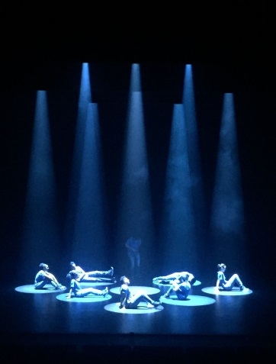
Set
No set. Smoke is used. Black walls and black floor. White cyc for ending.

