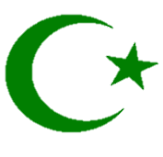
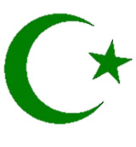
Y8 ISLAM
KNOWLEDGE ORGANISER
Overview  Around 2.5 million Muslims each year take part in the annual ‘hajj’ pilgrimage to Mecca. |  |  | Answers to Important Questions
Islam is one of the world’s major religions. It is the world’s 2nd largest religion, with about 1.8 billion followers.  Muslims are the people who follow Islam. They believe in one God who created everything – he is called Allah (the Arabic name for ‘God’).  Muslims believe in a messenger of Allah, named Muhammad. They view him as the final prophet, following Adam, Abraham, Moses, Jesus and others.  Muhammad is believed to be the person who founded the faith of Islam, about 1,400 years ago.  The holy book in Islam is called the Qur’an. A mosque is a building designed for Muslim worship. | 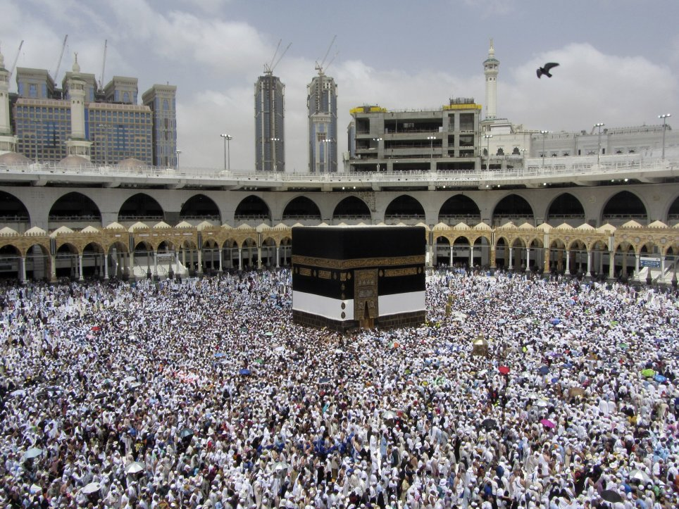 |  | Where do Muslims worship God? | 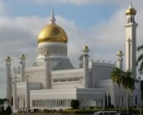  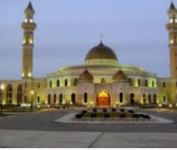 | -Muslims pray in a building called a mosque.  -The word for mosque in Arabic is ‘masjid.’ Most masjids have at least one dome, and many also have one or two towers.  -Muslims take off their shoes before entering the mosque to pray. This is a sign of respect.  -On Fridays at noon, the most important religious service of the week is held in the mosques.
 |  |  | What is the Qur’an? | 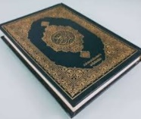 | The Qur’an is the holy book of Islam. Muslims believe that the Qur’an contains the holy words of God, which teaches them the right path. Other important books in Islam are the Sunnah (about Mohammad’s life) and the Hadith (the words of Mohammad).
 |  |  | Where do most Muslims live in the world? | 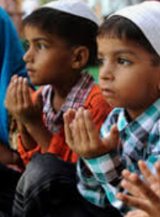 | -There are about 50 countries around the world in which Islam is the largest religion.  -The Arab world (the Middle East and Northern Africa) accounts for about 20% of all Muslims.  -There are also millions of Muslims from Indonesia, Pakistan, Bangladesh and India.  -China, Iran and Turkey also have many Muslims.  -After Christianity, Islam is the 2nd largest religion in most European countries.
Muslim Beliefs
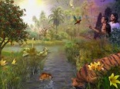  Laws and Customs  -There are many laws and customs outlined in the Qur’an, that Muslims should follow.  -They must dress modestly, e.g. many Muslims wear long clothes that cover their bodies, and women wear a hijab which covers parts of their hair/face. Food must be halal, meaning animals must be killed in a certain way. | 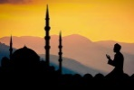  Ramadan  -Ramadan is the ninth month of the Islamic calendar. It is a month in which Muslims worldwide take part in fasting.  -For the whole of the month, Muslims do not eat during daylight hours. Instead, they devote themselves to prayer and to Allah. |  | How many different types of Muslims are there? | 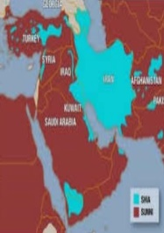 | -There are two main types of Muslims – Sunni Muslims and Shia Muslims. Although all Muslims follow the Qur’an and the five pillars of Islam, they also have some differences. Sunni Muslims believe that leadership of the community (and the ‘caliph’ – leader) should be elected from the community. Shia believe that leadership should stay within the prophet’s family, or be chosen by Allah.
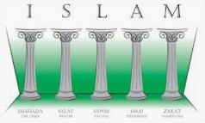
The Five Pillars of Islam

-The Five Pillars of Islam are the behaviours and beliefs by which Muslims must live their lives. They were founded in the hadith of Gabriel.

1. Shahadah: the declaration of faith: ‘There is no God but Allah, and Mohammad is his messenger.’ 2. Salah: the five daily prayers. 3. Zakat: Giving money to help the poor. 4. Sawm: Committing to fasting during the month of Ramadan. 5. Hajj: A religious pilgrimage to Mecca that Muslims should undertake at least once in their lives.
 |  |  | Top 10 Facts!
 |  |  | - Friday is the Muslim holy day. People go to the Mosque and pray.  - Islam is the fastest-growing religion in the world.  - Muhammad was born in Mecca – which is now in Saudi Arabia. It is considered a holy place.  - The very first mosque was in the courtyard of the home of the prophet Muhammad.  - The Ka’ba is an ancient shrine in Mecca that Muslims believe is the holiest place on earth. |  |  | - Muslims believe that Allah told Muhammad exactly what to write in the Qur’an.  - The Qur’an has a total of 144 chapters. Many Muslims try to memorise the entire Qur’an!  - Muslims are called to prayer by a muezzin, a man who sings through a loudspeaker.  - About 23% of the global population are Muslim.  - The ‘Islamic World’ refers to the Middle East, North Africa, and parts of South East Asia.
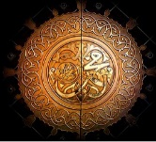
Muhammad

- Muslims believe that God sent his final message to Earth through Muhammad, 1400 years ago. He is considered so holy that Muslims say ‘peace be upon him’ whenever they say or write his name.

-When he was around 40 years old, Muhammad is believed to have been approached in a cave by the angel Gabriel, who sent ‘revelations’ from Allah. He continued to receive these messages, and to teach them to others.

-The messages that Muhammad received were later collected and made into the Qur’an. Muslims believe that they should follow the example set by Muhammad throughout their own lives.

c.1979CE: Iranian Revolution forms state of Iran – first attempt at an Islamic state.
Islam Timeline
c.1120CE: Islam spreads to South-East Asia.
c.633CE: Muhammad dies. Abu-Bakr made caliph (leader).
c.630CE: Muhammad returns to Mecca. People accept Islam.
c.622CE: Muhammad reaches Medina. Beginning of Islamic calendar.
c.655CE: Islam spreads from the Middle East through North Africa.
Beginning of time: Allah creates the world and everything in it.
Around 570CE: Muhammad is born in Mecca.
c.610CE: Muhammad receives the first revelation from Gabriel.

